
10007 Raven Wood Drive St. John, IN 46373 10007 Raven Wood Drive St. John, IN 46373
Phone: 219-515-2184 www.crystalcrowndentalmilling.com Phone: 219-515-2184 www.crystalcrowndentalmilling.com
Lab Name: _____________________ Patient Name:________________________ Lab Name: _____________________ Patient Name:________________________
Date:_______________ Requested Return Date:________________ Date:________________ Requested Return Date:________________
TOOTH NUMBER(S):_____________ SHADE: __________ TOOTH NUMBER(S):_________________ SHADE:____________
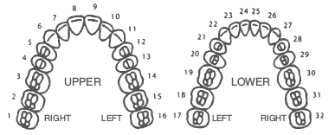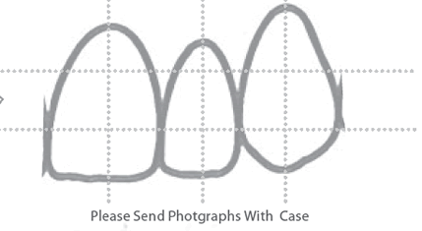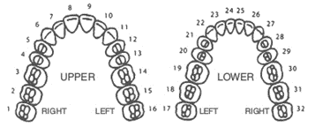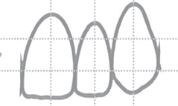

RESTORATION TYPE: SPECIAL: RX SPECIAL INSTRUCTIONS: RESTORATION TYPE: SPECIAL: RX SPECIAL INSTRUCTIONS:
- Coping(s) Stain & Glaze Coping(s) Stain & Glaze
- Coping Bridge Die Trim Coping Bridge Die Trim
- Full Crown(s) Full Crown(s)
- Full Crown Bridge Full Crown Bridge
- Facial Cutback Facial Cutback
- Copy Waxup *Extra Charge Copy waxup *Extra Charge
MATERIAL: MATERIAL:
- Sagemax NexxZr T ( PreShaded 1270 Mpa ) Sagemax NexxZr T ( PreShaded 1270 Mpa )
- Crystal Elite (1000 Mpa) Crystal Elite (1000 MPa )
- ZirCAD Prime ( Preshaded ) ZirCAD Prime ( Preshaded )
( 650 MPa Incisal / 1200 MPa Dentin ) ( 650 MPa Incisal / 1200 MPa Dentin )
- ZirCAD ESTHETIC Prime ( Preshaded ) ZirCAD ESTHETIC Prime ( Preshaded )
( 650 MPa Incisal / 850 MPa Dentin ) ( 650 MPa Incisal / 850 MPa Dentin )
- Crystal UT Multi Layer Plus Crystal UT Multi Layer Plus
( Preshaded 1050 MPa ) ( Preshaded 1050 MPa )
- EMax LT - Milled (Preshaded 360 MPa) EMax LT - Milled (Preshaded 360 MPa)
- EMax HT - Milled (Preshaded 360 MPa) EMax HT - Milled (Preshaded 360 MPa)
- Wax Wax
- PMMA Temporary (Preshaded) PMMA Temporary (Preshaded)

*Please use removable or separate dies with no glue or spacer of any kind. *Please use removable or separate dies with no glue or spacer of any kind.
*Large metal articulators must have removeable models to scan. *Large metal articulators must have removeable models to scan.

